# Assignment -1

Basic Python

|  |  |
| --- | --- |
| Assignment Date | 19 September 2022 |
| Team ID | PNT2022TMID34120 |
| Project Name | Project - AI - based localization and  classification of skin disease with erythema |
| Maximum Marks | 2 Marks |

1. SPLIT THE STRING:

s **=** "Hi there Sam!" s**.**split(" ")

OUTPUT:

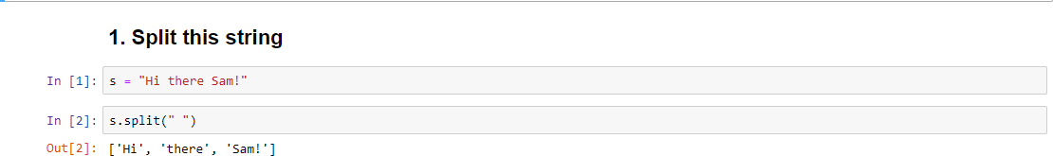

1. Use .format() to print the string. CODE:

planet = "Earth" diameter = 12742

print("The diameter of Earth is {} kilometers.".format(diameter))

OUTPUT:

1. 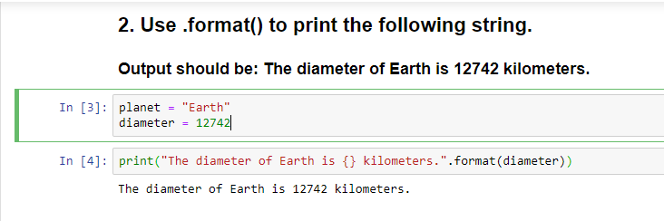In this nest dictionary grab the word "hello"

CODE:

d = {'k1':[1,2,3,{'tricky':['oh','man','inception',{'target':[1,2,3,'hello']}]}]} result=d['k1'][3]['tricky'][3]['target'][3]

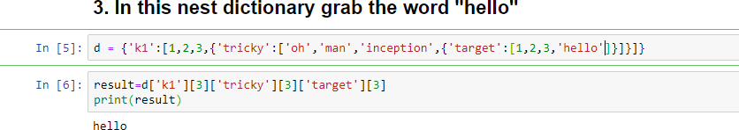print(result) OUTPUT:

# Create an array of 10 zeros and Create an array of 10 fives

**CODE:**

import numpy as np array=np.zeros(10) print(array) arr1=np.ones(10)*5 print(arr1)

OUTPUT:

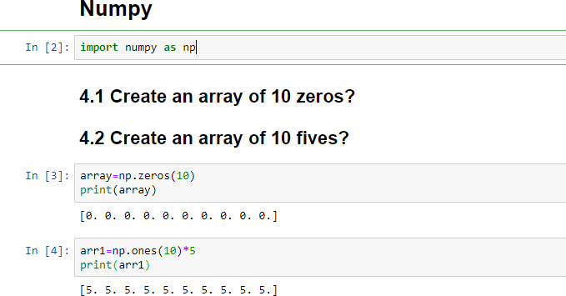

1. Create an array of 10 zeros and Create an array of 10 fives?

CODE:

array=np.zeros(10) print(array) arr1=np.ones(10)*5 print(arr1)

OUTPUT:

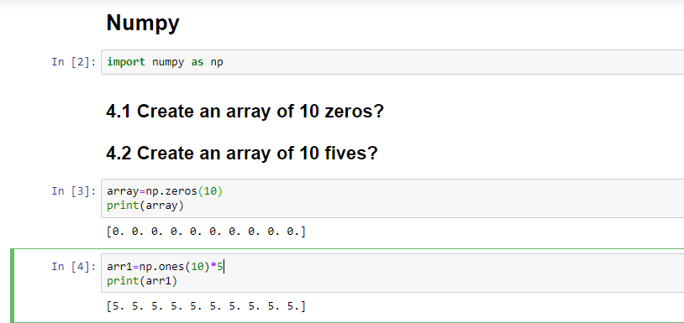

1. Create an array of all the even integers from 20 to 35 and Create a 3x3 matrix with values ranging from 0 to 8

CODE:

arr2=np.arange(20,35,2) print(arr2) x=np.arange(0,9).reshape(3,3) print(x)

OUTPUT:

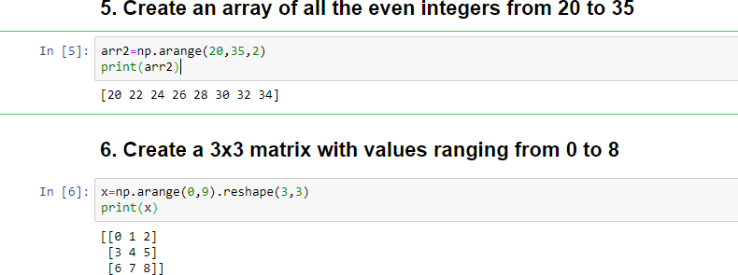

1. Create a dataframe with 3 rows and 2 columns CODE:

import pandas as pd import numpy as np

array=np.random.randint(10,size=(3,2)) array=([9,2,2],

[3,5,1],

[4,9,8],

[3,4,5])

df=pd.DataFrame(array) df

OUTPUT:

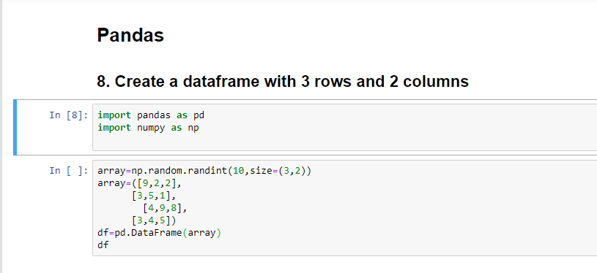

# Generate the series of dates from 1st Jan, 2023 to 10th Feb, 2023

CODE:

import pandas as pd

dRan3 = pd.date_range(start ='2023-01-01', end ='2023-02- 10').to_pydatetime().tolist()

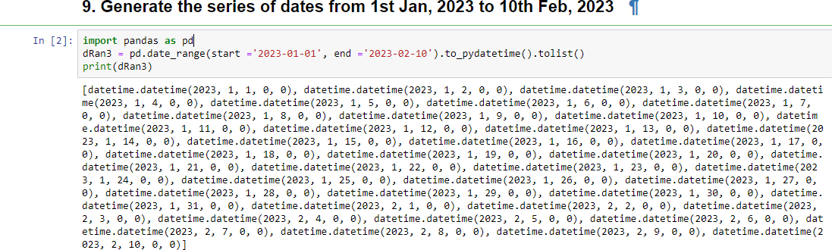print(dRan3) OUTPUT:

# Create 2D list to DataFrame

lists = [[1, 'aaa', 22], [2, 'bbb', 25], [3, 'ccc', 24]]

df = pd.DataFrame(lists, columns =['ID', 'number','no']) print(df)

OUTPUT:

